**Strategy about future**

**Material and Human resource**

As it is seen page (relevant factors tech) charging station hardware cost and labor costs have the biggest shares of charging stations. While the charging station technology advancing, other labor costs (other than electrician labor) increase. This shows that advancing technology in charging stations requires highly skilled human resources. Human Resource departments of charging station companies should focus to solve this problem for future. Hardware costs of charging stations in the future will down and charging stations should be easy to setup and use. But it is also solved by understanding the laws and regulations because usage of high level electricity related products covered by laws. Easy and more secure ways to set up charging stations can also decrease the costs.

**EVs battery**

Future developments in EVs battery will always play a key role in both EVs and EVs charger industry. Not just cost issue but also technological innovations are also bounded with charger technology and industry. There are many important specifics about battery such as cost parity, range parity, charging, swapping, refilling, lifespan and safety. In order to have competitive advantage in EVs charging industry, it is vital to be updated and ready for innovations in EV battery technologies.

**Charging speed**

Decreasing cost of fast DC chargers with developments in manufacturing these systems will provide big advantage for EVs and EVs charging station market.

**Home battery**

***[EVs chargers will not just connect cars to grid in order to buy and sell electricity but also communicate and cooperate with home batteries to manage energy supply and demand of a house as being player of energy market.]***

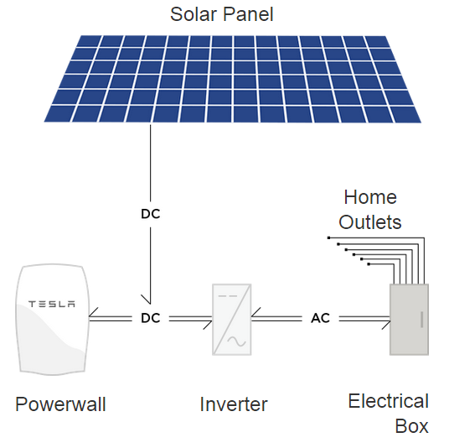Tesla Energy developed an innovative product as home battery that is called Powerwall. “*Home battery that charges using electricity generated from solar panels, or when utility rates are low, and powers your home in the evening. Powerwall offers independence from the utility grid and the security of an emergency backup. Without a home battery, excess solar energy is often sold to the power company and purchased back in the evening. This mismatch adds demand on power plants and increases carbon emissions. Powerwall bridges this gap between renewable energy supply and demand by making your home’s solar energy available to you when you need it.”[1]*

This innovative factor will have great impact on our understanding about energy market and grid systems most probably. After this kind of home batteries become common, EVs charger will not be just a bridge between grid and EVs. There will be three actors in the energy system as Smart Grid, home battery and EVs. All will be simply energy buyer and seller. This innovation will become real product in summer of 2015 in U.S. market. EVs charging manufacturers must consider possible effects of this new technology on EVs charging systems.

**Wireless Charging**

**Maintenance**

It seem that advancements of these systems’ technology in the future may require high skilled labor but low cost of spare parts because of developments on manufacturing EVs charging stations.

**Blockchain Technology**

1. <http://www.teslamotors.com/powerwall>